Minute Book Page 18344

Minutes of the Roanoke Rapids City Council
A special meeting (Budget Work Session) of the City Council of the City of Roanoke Rapids was held on Wednesday, May 25, 2016 at 3:30 p.m. in the first floor conference room of the J. Reuben Daniel City Hall & Police Station.

Present: Emery G. Doughtie, Mayor
Ernest C. Bobbitt)
Council Members
Suetta S. Scarbrough)
Carol H. Cowen)
Wayne Smith)
Joseph Scherer, MPA, MS, City Manager
Lisa B. Vincent, MMC, NCCMC, City Clerk
Leigh Etheridge, Finance Director
Kathy Kearney, Deputy City Clerk/Human Resources Manager
Kelly Lasky, Planning & Development Director
Larry Chalker, Public Works Director
Chuck Hasty, Police Chief
John Simeon, Parks & Recreation Director
Stacy Coggins, Fire Chief

City Manager Scherer stated the objective today is to confirm the major expense items Council members indicated at the last budget work session that they would like to see funded. He reviewed the following list of those items:
ITEM | COST | COMMENTS
PD Cars | $160,000 | (4) Ford Interceptors
Refuse Vehicle | $190,000 | Public Works
(3) Entry Level Personnel | $120,000 | Public Works
Trash Carts | $ 30,000 | Public Works
Road Maintenance | $100,000 | Public Works
Mower Replacement | $ 36,000 | (2) each, PW and P & R
P & R Facility | $ 25,000 | HVAC replacement
PD Guns | $ 12,500
New K-9 | $ 0 | One animal recently ruled unreliable
Library Carpet | $ 12,000
Air Packs | $ 60,000 | FD Need
P & D SUV | $ 25,000
P & R Truck | $ 25,000
P & R Tractor | $ 15,000
Items in RED are designated for funding through Loan (Total: $511,000).
Minute Book Page 18345
May 25, 2016 Special Meeting

City Manager Scherer stated a couple of department heads have some changes they would like to discuss with Council.

Public Works Director Chalker stated he has no issues with the items on the City Manager’s list. He stated his department will take those items, move forward and make the best of them.

Chief Coggins stated he is content with the air packs the Council has graciously agreed to fund.

Councilman Bobbitt asked how many air packs he can get for $60,000.

Chief Coggins stated six. He stated that will leave them with seven more to get next year.

Councilman Bobbitt asked if they have a few on reserve.

Chief Coggins stated they keep the older ones serviced.

Parks & Recreation Director Simeon stated he is good with the list but did want to discuss the T. J. Davis Supervisor position he had requested. He asked that he be allowed to fill that position in lieu of the Program Leader position that is now vacant with the promotion of Thomas Goble to Senior Center Supervisor. He stated he feels the supervisory position will better fill some of the personnel needs they have. Parks & Recreation Director Simeon stated he feels he can find the $12,000 difference in salary within his current budget to cover the position.

Councilman Smith asked the total salary of the supervisory position.

Parks & Recreation Director Simeon stated a little over $51,000. He stated the T. J. Davis Supervisor position has been frozen for four years and it is causing some personnel issues. He stated, as mentioned at earlier budget meetings, the Parks Maintenance Supervisor is filling in on a day to day basis along with other administrative staff, and the Assistant Director is not able to do what she needs to do.

Mayor Pro Tem Ferebee asked if this would be a wash.

Minute Book Page 18346
May 25, 2016 Special Meeting

Parks & Recreation Director Simeon stated it would. He stated he would find the difference within his current budget.

Councilman Bobbitt stated he does not have anything against the Parks & Recreation Department but we are cutting air packs and guns—things that are used daily for public safety. He stated he realizes that this position would also work daily but feels since this position has been vacant for four years, the department could continue to rotate people for at least another year until we see what happens with the Theatre. Councilman Bobbitt stated with money like it is, $51,000 is a lot of money. He stated we could not fund the $40,000 position in the Planning & Development Department.

Mayor Pro Tem Ferebee asked Parks & Recreation Director Simeon if he feels he could find the $12,000 difference within his current budget.

Parks & Recreation Director Simeon stated yes.

Councilman Smith stated this is kind of a no-brainer.

Mayor Pro Tem Ferebee stated if it can be a full wash, he has no problems with doing this.

Councilman Smith asked Parks & Recreation Director Simeon where he would take the money from.

Parks & Recreation Director Simeon stated he does not have an answer to that yet but he will find it. He stated he would probably take a little out of each call center.

Councilman Smith asked if he would be taking anything out of his maintenance accounts.

Parks & Recreation Director Simeon stated no.

Councilman Smith stated he has no problem with this.

Chief Hasty stated he originally asked for funding for shotguns and handguns. He stated when City Manager Scherer asked him what he would prefer, he said handguns. He stated he requested funding for the full amount of handguns needed. He stated it is hard to decide which officer
Minute Book Page 18347
May 25, 2016 Special Meeting

gets the new handguns. He stated if Council cannot fund the full amount for all of the handguns, he would request funding of two K-9s—for tracking and narcotics. He stated hopefully with these dogs we can get enough money from drug forfeitures to purchase the handguns. He requested the funding of either all of the handguns or two K-9s.

Councilman Bobbitt asked Chief Hasty if he has people to handle the dogs.

Chief Hasty stated we have two that have gone to training and are helping out with the one we have.

Councilwoman Cowen suggested cutting back on one police vehicle.

Chief Hasty stated we have 11 vehicles that are 2007 models. He stated at some point it will all come to a head and they will break down.

Councilman Bobbitt stated if he gets these two dogs, he will then have three.

Chief Hasty stated that is correct.

Mayor Doughtie asked if we have funding in the budget to maintain the dogs.

Chief Hasty stated yes. He stated we have a line item in the budget.

Councilman Bobbitt asked if he has the funds to cover shots.

Chief Hasty stated yes. He stated they get the dog food free from Purina.

Mayor Pro Tem Ferebee stated he has a different view on this. He stated if you need the guns, you need the guns. He stated he would hate to see a gun fail at the wrong time. He stated the department may or may not get enough drug forfeiture funds to purchase the guns.

Chief Hasty stated he would prefer the guns.

Councilwoman Cowen asked Chief Hasty if he has a person to handle the dogs.

Minute Book Page 18348
May 25, 2016 Special Meeting

Chief Hasty stated yes.

Councilman Smith stated it is hard to make a decision when we do not know what the total budget will be.

Mayor Pro Tem Ferebee pointed out that staff needs the information and feedback from these meetings to come up with a total budget. He stated we still might have to come back and make some more cuts.

City Manager Scherer stated he needs a decision from Council on the major items to fund. He stated he will take the decisions made today and have that information ready to present to Council at the special meeting next Tuesday.

Councilwoman Cowen stated we need to know what that will be before we get in front of the public.

City Manager Scherer stated the budget will not be any different from the budget we started out with at the beginning of this fiscal year.

Councilman Smith stated it seems like it would be easier if the department heads had their budgets and determined how to spend those funds based on their needs.

City Manager Scherer stated that would be an internal decision within each department. He stated all he is looking for is a decision on the major expense items. He stated for the operational budget, we are looking at the same amounts we started with this fiscal year.

Councilman Smith stated he thought at the last budget work session, we were going to finance around $583,000. He stated the amount shown today is a reduction.

City Manager Scherer stated we then discussed funding the three positions in the Public Works Department in lieu of funding the rubber tire loader.

Councilman Smith stated he feels the guns can be added to the amount for financing. He stated if we finance $25,000 to $30,000 more, it will not increase the payments that much.

Minute Book Page 18349
May 25, 2016 Special Meeting

City Manager Scherer stated he is just going by what was discussed at the last work session.

Councilman Bobbitt stated after the last work session, the City Manager met with the department heads. He asked City Manager Scherer when all of these changes, such as changing positions, were brought up.

City Manager Scherer stated in the last day or two.

Councilman Bobbitt stated we have been talking about these major expense items at the last four or five meetings. He stated these were the most important things and they should have been talked about then. He stated we need to stand by what we said at the last work session. He stated he hates making changes at the eleventh hour and it seems to be happening more and more.

Mayor Pro Tem Ferebee suggested funding more of the tangible items if it would not make that much difference in the payment. He stated we all take out loans and make payments in our personal lives if there is something big we need.

City Manager Scherer stated with financing the $511,000 for six years, our payment will be $91,200 a year.

Councilman Smith stated we have one payment that will be coming off soon.

Finance Director Etheridge pointed out that $77,000 will be coming off.

Councilman Bobbitt suggested financing all of the handguns and the rest of the air packs. He stated some things are more important than others. He asked if the position at the Parks & Recreation Department would be a wash.

Parks & Recreation Director Simeon stated yes.

Mayor Pro Tem Ferebee stated he has no problem with that position as long as it is a wash.

Mayor Doughtie stated it sounds like the concern about adding a position is that it is something that could potentially increase in cost such as salary and benefits.
Minute Book Page 18350
May 25, 2016 Special Meeting

Mayor Pro Tem Ferebee stated we look at our department heads to stay within their budgets and we do not need to micromanage that.

City Manager Scherer stated so far, the department heads have done a good job staying within their budgets. He pointed out that we are not asking for any additional funding for operating budgets.

Councilwoman Cowen stated this meeting is not only about financing but it is about the concerns of the department heads and wanting to make sure they were comfortable with the major items proposed for funding. She stated we cannot keep borrowing. She stated we will have to raise taxes.

Mayor Doughtie stated if things continue like they are, we are going to be out of money. He stated if we continue like this, in the next five years we will be just about out of fund balance and the people in Raleigh will be coming here to tell us what to do.

Councilwoman Cowen stated she is getting an uncomfortable feeling with all of this discussion about borrowing, borrowing and borrowing. She stated we are losing population and we are not generating extra dollars.

Councilman Smith stated we are getting hung up on $12,500. He stated we need to let the Chief decide how to spend it. He stated we have one debt payment coming off. He asked the date of the last payment on that debt.

Finance Director Etheridge stated November 2017.

Mayor Pro Tem Ferebee asked City Manager Scherer if the items on the list will be included in the budget presented to Council next week.

City Manager Scherer stated yes.

Planning & Development Director Lasky stated she has expressed in prior meetings the need for additional staff. She stated there will have to be some drastic changes made if her department does not get some help. She explained that the City’s inspection division is required to enforce the NC Building Code. She stated that is the one function the City is required by North Carolina General Statutes to provide.

Minute Book Page 18351
May 25, 2016 Special Meeting

Planning & Development Director Lasky stated last fall, the legislature made changes that all revenues coming into inspection departments have to go back into that department’s operating budget and that revenues cannot exceed expenditures. She stated the following chart shows annual building valuations from 2000 – 2016 and the anticipated permit fees from three proposed major projects: (1) Manning Elementary School; (2) SECU and (3) MaSuKi Apartments:

[Remainder of page intentionally left blank.]

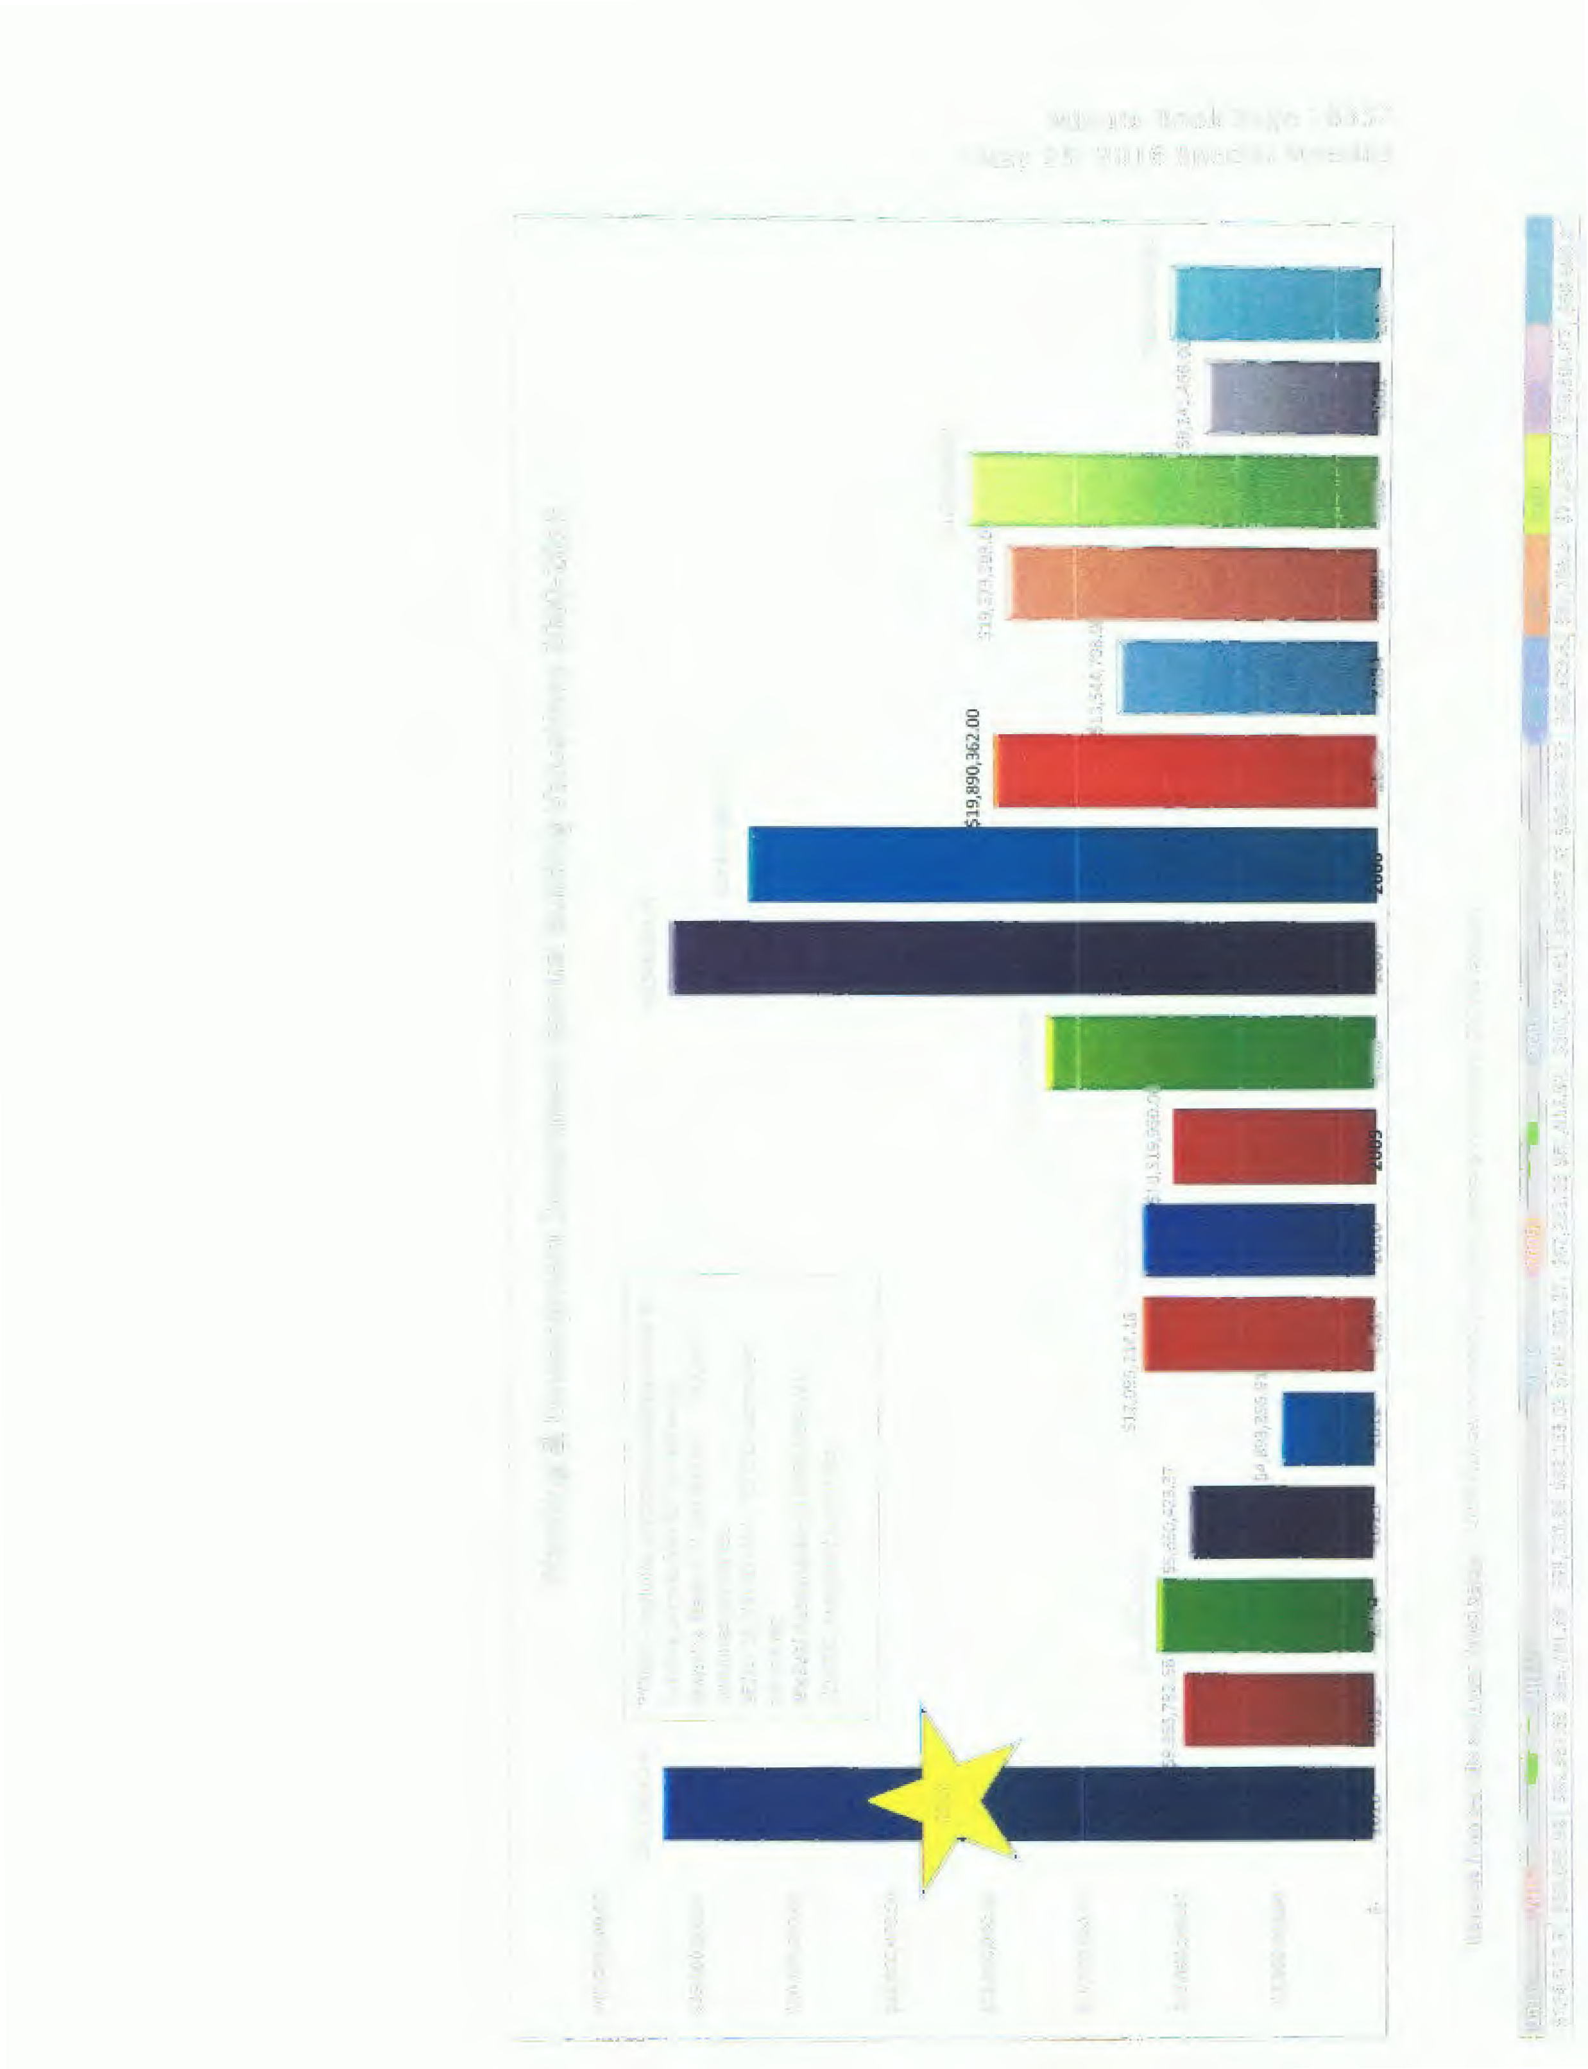
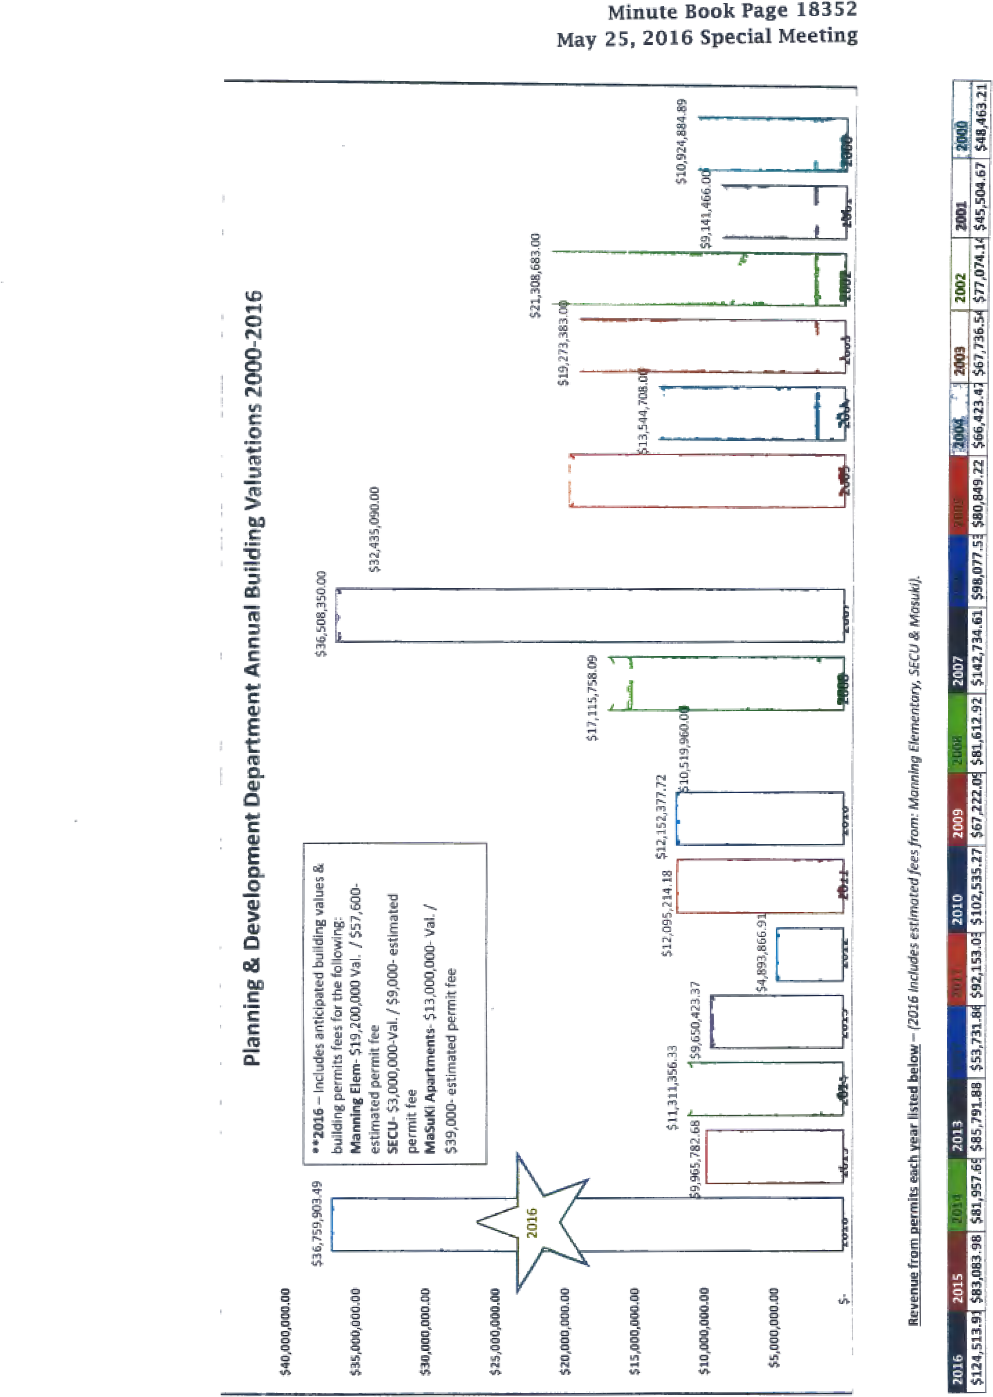
Minute Book Page 18353
May 25, 2016 Special Meeting

Planning & Development Director Lasky pointed out that the construction value for 2016 is approximately $36.5 million and the last time it broke $36 million was in 2007. She stated at that time, there were 8 full-time employees in the Planning & Development Department: the Planning & Development Director; 3 Building Inspectors; 2 Minimum Housing Code Officers and 2 Administrative Assistants. She stated they now have 5 full-time staff members.

Planning & Development Director Lasky stated she has a critical need for addressing complaints and violations. She stated it is impossible to keep up with the current demands and workload sitting on the shelf. She asked that Council reconsider funding the Planner position. She stated the anticipated salary including benefits is approximately $54,000.

Planning & Development Director Lasky stated the consequences if we do not get additional staff is that we will have to look at implementing quotas. She stated inspections are required by law to be done in a timely manner. She stated if we cannot keep up, we will not be able to issue permits.

Planning & Development Director Lasky stated she appreciates the vehicle but if she had to choose between the vehicle and additional staff, she would rather have the position. She stated they can find a way to get around town even if they have to use their personal vehicles.

Councilman Smith stated $57,600 is the building permit fee for Manning Elementary School.

Planning & Development Director Lasky stated that is correct. She also pointed out that this does not include electrical and plumbing permits.

Councilman Smith stated the permit fees would pay for the salary for the first year.

Councilwoman Scarbrough asked Planning & Development Director Lasky if she said earlier that the State Legislature requires permit fees to come back to the department.

Planning & Development Director Lasky stated that is correct. She stated by funding this position, you will see more code enforcement in the neighborhoods of the City.
Minute Book Page 18354
May 25, 2016 Special Meeting

Councilman Smith stated he does not see any problem with reinstating this position in the Planning & Development Department.

City Manager Scherer stated he was hesitant about recommending any new staff but the fees will provide the funding of this position.

Councilman Smith stated the position will pay for itself.

Mayor Doughtie stated the community deserves more code enforcement.

Planning & Development Director Lasky stated the additional staff could go out and find a lot of code violations. She stated she works between 60 and 70 hours each week and gets paid for 40 hours. She stated she is not saying this to complain but to let Council know that the demand is needed. She stated everything they do is service-oriented.

Mayor Doughtie stated since Planning & Development Director Lasky has come to Roanoke Rapids she has moved forward with her career and the City is better off. He stated if we can do something to increase the productivity of this department, he would like for us to do it.

Councilman Smith stated he feels we should go ahead and tell the City Manager to work this out.

Mayor Pro Tem Ferebee stated he personally does not have a problem with this but we are still looking at the bottom line. He stated it all depends on what comes back to us when the budget is presented. He stated what we have discussed today might make sense now but if the numbers are not right, he may say “no”.

City Manager Scherer stated we will need to reschedule the June 7 Council meeting to June 14 in order to allow the 10 days required for the budget to be on public display after it is presented next Tuesday. He stated the public hearing would be held on June 14 with adoption planned for June 21.

Mayor Doughtie stated right now we are looking at financing between $500,000 and $600,000, and taking $500,000 from fund balance.

Minute Book Page 18355
May 25, 2016 Special Meeting

City Manager Scherer stated we are looking at taking $1 million from fund balance.

Mayor Doughtie asked how much we have in fund balance.

Finance Director Etheridge stated $4.3 million.

Mayor Pro Tem Ferebee asked the percentage of the fund balance if we take the $1 million.

City Manager Scherer stated it would take it to 17%.

Councilman Smith stated we need to let the department heads decide on what they want to do with their budgets.

City Manager Scherer stated they do that every week.

Councilman Bobbitt asked if we are including the seven additional air packs in the loan.

City Manager Scherer stated yes, along with the handguns.

After a brief discussion regarding the K-9s, it was decided that no additional monies would be budgeted for the dogs.

Mayor Doughtie asked if we have found out any more information on the health insurance.

City Manager Scherer stated he has just received new information and has not had a chance to review it. He stated he plans to do that before leaving today.

There being no further discussion, the meeting adjourned.

Lisa B. Vincent, MMC, NCCMC, City Clerk

6/14/2016
Approved by Council Action on:

