Minute Book Page 18034

Minutes of the Roanoke Rapids City Council
A regular meeting of the City Council of the City of Roanoke Rapids was held on Tuesday, January 5, 2016 at 5:15 p.m. in the Council Chambers at the Lloyd Andrews City Meeting Hall.

Present: Emery G. Doughtie, Mayor
Carl Ferebee, Mayor Pro Tem
Ernest C. Bobbitt)
Suetta S. Scarbrough)
Council Members
Carol H. Cowen)
Wayne Smith)
Joseph Scherer, MPA, MS, City Manager
Gilbert Chichester, City Attorney
Lisa B. Vincent, MMC, NCCMC, City Clerk
Kathy Kearney, Deputy City Clerk/Human Resources Manager
Leigh Etheridge, Finance Director
Larry Chalker, Public Works Director
John Simeon, Parks & Recreation Director
Kelly Lasky, Planning & Development Director
Stacy Coggins, Fire Chief
Chuck Hasty, Police Chief
Christina Caudle, Main Street Director

Mayor Doughtie called the meeting to order and opened the meeting with prayer.

Adoption of Business Agenda

There being no conflict of interest with any of the items on the agenda, motion was made by Councilman Smith, seconded by Councilman Bobbitt and unanimously carried to adopt the business agenda for January 5, 2016 as presented.

Minute Book Page 18035

Mayor Doughtie stated he was informed that today is our City Attorney’s birthday. He wished him a happy birthday and thanked him for his guidance and wisdom. He stated he shudders to think of some situations we would be in without his guidance.

Special Recognitions

Recognition of Recent Police Department Promotions
Police Chief Hasty recognized the promotion of Andy Bryant from Administrative Lieutenant to Patrol Captain. He stated Andy has 24 years of law enforcement experience working with the Roanoke Rapids Police Department.

Police Chief Hasty recognized the promotion of Bobby Martin from Investigator to Criminal Investigations Division (CID) Captain. He stated Bobby has 21 years of law enforcement experience working with Warren County, Weldon, Halifax County and the Roanoke Rapids Police Department.

Police Chief Hasty welcomed both Andy and Bobby to the administrative team of the Roanoke Rapids Police Department.

Mayor Doughtie stated he appreciates the service of both Andy and Bobby to our community, and he congratulated them on their promotions.

Approval of Council Minutes

Motion was made by Councilman Bobbitt, seconded by Councilwoman Cowen and unanimously carried to approve the December 15, 2015 Council Minutes.

City Council Appointments/Reappointments

Firemen’s Relief Fund Board of Trustees & Roanoke Canal Commission
A ballot vote was taken and City Clerk Vincent announced that Dennis Gaylor received the unanimous vote for reappointment to the Firemen’s Relief Fund Board of Trustees, and Greg Lawson received the unanimous vote for appointment to the Roanoke Canal Commission.

Minute Book Page 18036

Motion was made by Mayor Pro Tem Ferebee, seconded by Councilwoman Scarbrough and unanimously carried to reappoint Dennis Gaylor to the Firemen’s Relief Fund Board of Trustees and to appoint Greg Lawson to the Roanoke Canal Commission.

Public Hearings

Consideration of Rezoning Request from Gil Cunningham to Rezone Approximately 83 Acres at 395 Wallace Fork Road from B-4 Commercial-Entertainment Overlay District to I-2 Industrial District
Planning & Development Director Lasky reviewed the following staff report with Council:

MEMORANDUM

To: Joseph Scherer, City Manager

From: Kelly Lasky, Planning & Development Director/s/

Re: Rezoning Request (map attached) – Amendment to the Roanoke Rapids Zoning Map to Rezone 83.3+/- Acres of Property at 395 Wallace Fork Road from B-4 Commercial District-Entertainment Overlay District to I-2 Industrial District

Date: December 28, 2015

Summary Overview
Subject Property |  | 83.3+/- acres of property located at 395 Wallace Fork Road with road frontage along Wallace Fork Road and Aurelian Springs Road
Proposal |  | Rezone from B-4 Commercial District with Entertainment Overlay District to I-2 Heavy Industrial District
Applicant |  | Gil Cunningham
Property Owner |  | Carolina Dirt, LLC
Present Use |  | Cleared, undeveloped land, previously utilized as an outdoor concert venue
Proposed Use |  | Not stated in application
Staff Recommendation |  | Approve

When evaluating a rezoning request, it is appropriate to consider ALL permissible uses in the requested zoning district. City Council cannot specifically limit which uses are allowed (or not) as a result of any rezoning consideration.

Minute Book Page 18037

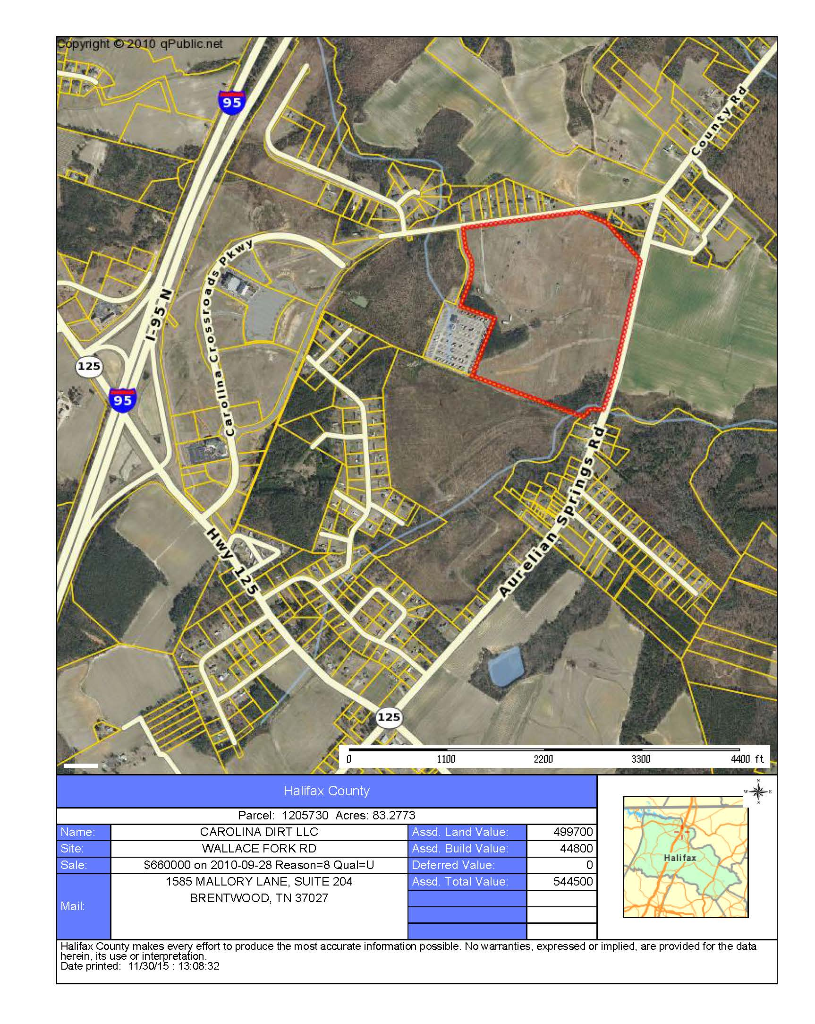
Consider impacts on/from:
- potential uses
- neighbors
- general public
- traffic
- utilities
- neighborhood character
- schools

Omit from Consideration:
- ethnicity
- religion
- income
- rent or own

Analysis and Detail:

1. Applicant and Property Owner

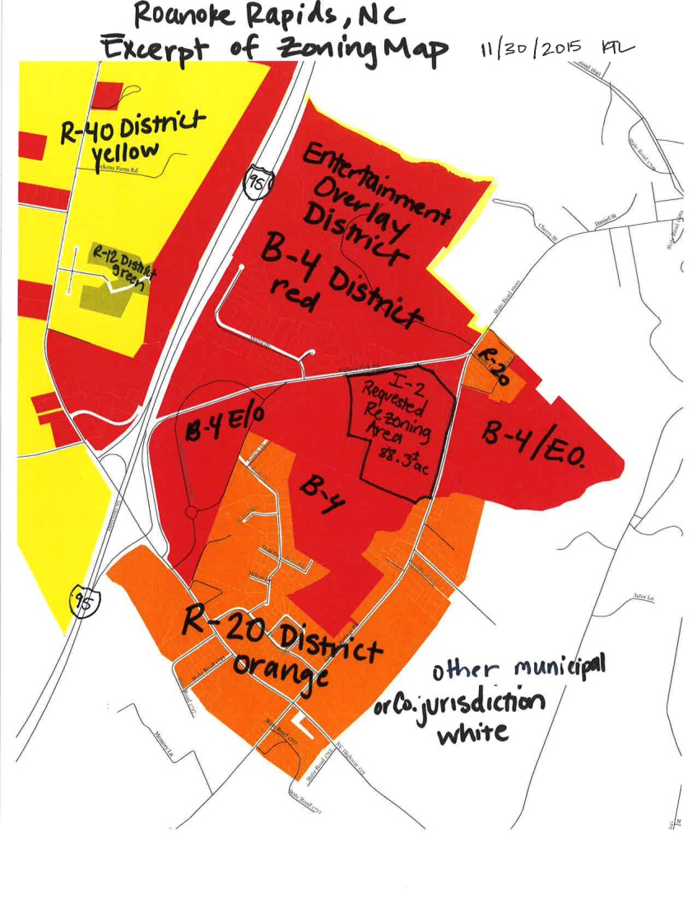
The applicant is Gil Cunningham, 1243 Monarch Way, Brentwood, TN 37027; (615) 497-3822. According to the Halifax County tax listing, the property owner is Carolina Dirt, LLC, 1585 Mallory Lane, Suite 204, Brentwood, TN 37027.

2. Location/Area Description

The site proposed for rezoning is located east of Interstate 95 in the area referred to as “Carolina Crossroads” Music and Entertainment District. In the year 2006, the site was originally part of the establishment of the Roanoke Rapids Entertainment, LLC subdivision and sold to Carolina Dirt, LLC in September 2010. The Entertainment District is popularly known for the developments of the Hilton Garden Inn, the Roanoke Rapids Theater, and the Carolina Crossroads (RV) Recreational Vehicle Park.
The location of the site proposed for rezoning is addressed 395 Wallace
Minute Book Page 18038

Fork Road. The 83.3+/- acre site has approximately 1,372 feet of street frontage along Wallace Fork Road (SR 1692) and 1,800 feet of street frontage along Aurelian Springs Road (SR 1600). The site is currently zoned B-4 Commercial District with Entertainment Overlay District (EOD) jurisdiction.

The area to the southeast of the site proposed for rezoning has an R-20 Residential zoning classification and is developed as single-family residential use.

The adjacent areas to the east, north, south and west of the site proposed for rezoning are commercially zoned B-4 with EOD. The rezoning site is located adjacent (east of) the Carolina Crossroads RV Park (a conforming use in the EOD District).

There are nine (9) properties along Wallace Fork Road (north of the subject site) that are developed as single-family residential mobile homes. There is one property to the northeast of the site along Aurelian Springs Road that is developed as a single-family residential, conventional home. The residential use of these properties is designated as a grandfathered, legal, non-conforming use of the land in the B-4 EOD District. The single-family residential use of these properties was made unlawful by the Land Use Ordinance use regulations when the B-4 Commercial District was established in the area. Since the residential use was lawful prior to the establishment of the current zoning classifications, the non-conforming residential use of the properties may continue subject to Article VIII of the Ordinance.

The property to the east and south of the site proposed for rezoning is generally characterized as undeveloped, rural, agricultural use.

3. Existing and Proposed Zoning

The excerpt of the zoning map (item 2, page 2) delineates the existing zoning of the area being considered for rezoning and the zoning of the adjacent parcels. The requested rezoning area is currently zoned B-4 Commercial District with Entertainment Overlay District (EOD) jurisdiction. The requested zoning is I-2 (Heavy) Industrial District. The subject rezoning site is predominantly surrounded by the B-4 Commercial District with Entertainment Overlay District and has a minor adjacent area zoned R-20 Residential District.

The rezoning request is a change from B-4 Commercial District with EOD to I-2 (Heavy) Industrial District.

The following provides general descriptions of the existing and proposed zoning districts:

The R-20 district is designed to accommodate single-family dwelling units. Lots in the R-20 district are required to have a minimum density of 20,000 square feet, 100 feet in width and building setbacks of 30 feet from the street right-of-way property line and 10 feet from all other property lines.

The B-4 district is designed to accommodate the widest range of commercial activities with no minimum density (square footage) and a lot width of 70 feet. Setbacks from the street right-of-
Minute Book Page 18039

way property line are 20 feet and the distances from other property lines are determined by the rating of the exterior wall of construction.

The Entertainment Overlay District (EOD) is located over all B-4 commercial district properties in the designated Carolina Crossroads area. The density and dimensional requirements of the B-4 district are applicable in the EOD. The EOD is unique in that it allows only uses permitted in the Table of Permissible Uses in the Entertainment Overlay District (Land Use Ordinance Article XXIV, Section 151-363).

The uses allowed in each zoning district are identified in Section 151-149 Table of Permitted Uses (attached) of the City of Roanoke Rapids Land Use Ordinance. The specific uses permitted in the Entertainment Overlay District are indicated in Section 151-363 and are as follows:

Table of Permitted Uses in the Entertainment Overlay District
Use | By Right | By Special Use Permit | By Conditional Use Permit
ABC stores | X
Accessory Uses | X
Antiques | X
Arcades | X
Art galleries | X
Arts & craft shops | X
Athletic fields | X
Aquariums | X
Bakeries | X
Banks | X
Bars | X
Boating | X
Book stores | X
Bowling alleys | X
Bumper cars | X
Bungee jumps | X
Candy, ice cream, etc. shops | X
Car washes | X
Clothing shops | X
Coliseums & Stadiums |  | X
Comedy club | X
Convenient marts | X
Department stores | X
Dwellings, multi-family residence |  | X
Fuel sales | X
Gift shops | X
Golf courses | X
Golf, miniature | X
Hobby & game shops | X
Hotels | X
Home furnishings | X
Jewelry shops | X
Libraries | X
Motels | X
Motor vehicle raceway |  |  | X
Movie theaters | X
Multi-use outdoor recreation facility |  |  | X
Museums | X
Nightclubs | X
Parks | X
Parks – RV | X

Minute Book Page 18040

Table of Permitted Uses in the Entertainment Overlay District
Use | By Right | By Special Use Permit | By Conditional Use Permit
Parks – Water | X
Pharmacies | X
Photography studios | X
Public buildings/services | X
Restaurants | X
Roller coasters | X
Signs, off premises |  | X
Signs, on premises | X
Skateboard parks | X
Skating rinks | X
Special events | X
Specialty food shops | X
Subdivisions – major |  | X
Subdivisions – minor | X
Swimming pools | X
Tennis, racquetball, etc. courts | X
Theaters – drive-in | X
Theaters – dinner | X
Theaters – movie | X
Theaters – outdoor amphitheater | X
Theaters – performing arts & music | X
Towers – less than 50' | X
Towers – greater than 50' |  | X
Transportation facilities |  | X
Urgent care facilities | X
Utilities – public | X
Vehicle sales – recreation vehicles | X
Winery/Distillery | X

Industrial districts (I-1 and I-2) are established primarily to accommodate enterprises engaged in the manufacturing, processing, creating, repairing, renovating, painting, cleaning, or assembling of goods, merchandise, or equipment. The districts differ primarily in the permitted intensities of the development (I-1 light industry and I-2 heavy industry) and differ in the minimum dimensional requirements. There are no minimum density (square footage) requirements in the industrial districts. An I-1 (light industry) zone is designed for a minimum lot width of 50 feet and building setbacks of 30 feet from the street right-of-way property line and 15 feet from all other property boundaries. An I-2 (heavy industry) zone is designed for a minimum lot width of 100 feet and building setbacks of 40 feet from the street right-of-way property line and 25 feet from all other property boundaries. Building height (highest vertical elevation) is limited to 45 feet in both industrial zones (building height in a residential district is limited to 35 feet).

Any proposed construction and site plans are evaluated by City staff and the Development Review Committee to ensure a proper design. The Development Review Committee includes the Sanitary District, NCDOT, Public Works, NC Dominion Power, Fire Department and Code Enforcement.

The following table on the next page shows the Industrial Use District Uses. The Approval Process: letter “P” (Planning Department, Development Review Committee); letter “C” (Planning Department, Development Review Committee, Planning Board, Public Hearing, City Council):

Minute Book Page 18041

All Industrial Districts, I-1 Light Industrial and I-2, Heavy Industrial | P | Convenience Stores
 | P | Wholesale Sales and Rental of Goods, Merchandise and Equipment
 | P | Office, Clerical, Research and Services not Primarily Related to Goods or Merchandise Indoor/Outdoor Operations designed to attract little/no customer/client traffic other than employees operating the use
 | P | Banks with Drive-In Windows
 | P | Manufacturing, Processing, Creating. Repairing, Renovating, Painting, Cleaning, Assembling of Goods, Merchandise and Equipment Indoor and Outdoor
 | P | Trade or Vocational School
 | P | Churches, synagogues, and temples
 | P | Social fraternal clubs and lodges, union halls, and similar uses
 | P | Recreational, Amusement, Entertainment bowling alley, skating rinks, indoor tennis, billiard and pool halls, indoor athletic and exercise facilities, Movie Theaters
 | C | Coliseums, stadiums and other facilities designed to accommodate more than 1,000 people
 | P | Publicly –owned and operated outdoor recreation facilities
 | C | Golf Driving Ranges, miniature golf, skateboard parks, water slides
 | C | Horseback Riding stables
 | C | Automobile and Motorcycle Racing Tracks
 | C | Drive-In Movie Theaters
 | P | Restaurants, Bars, Nightclubs* (*nightclubs subject to location criteria, additional setbacks from residential dwellings)
 | P | Motor vehicle repair and maintenance, not including substantial body work
 | P | Motor vehicle painting and body work
 | P | Gas Sales
 | P | Car wash
 | P | Automobile Parking Garages and Parking Lots (no principal use)
 | P | Storage of Goods not related to sale or use of those goods on the same lot where they are stored  Indoor and Outdoor, including ministorage
 | P | Parking of vehicles or storage of equipment outside enclosed structure where: i. Vehicles/Equipment owned by lot occupant and ii. Parking/Storage is more than minor and incidental use of lot
 | P | Services and Enterprises related to Animals
 | P | Emergency Services Police, Fire, Rescue Squad, Ambulance, Civil defense, indoor training facility
 | C | Outdoor training facility
 | P | Agricultural Operations
 | P | Post office
 | P | Military Reserve, National Guard
 | P | Dry Cleaner, Laundromat
 | P | Utility Facilities
 | P | Towers and antennas less than 50 feet in height
 | C | Towers and antennas greater than 50 feet in height
 | P | Nursery Schools, Day Care Centers
 | P | Transportation Facilities stations for bus/train, taxi stands
 | P | Solar Farm
 | C | Wind Farm* (*subject to additional regulations provided in Section 151-175)
 | C | Adult Establishments* (*subject to location criteria, additional setbacks from dwellings, churches, schools, libraries, daycare…)
I-1 | C | Electronic Gaming (internet Sweepstakes)* (*subject to location criteria, setbacks from church, schools, dwellings)
I-2 | C | Penal and Correctional Facilities
 | C | Scrap Materials, Salvage Yards, Junk Yards, Automobile Grave Yards
 | C | Mining or quarrying operations, including on-site sales of products
 | C | Reclamation landfill (process whereby old landfill disposal cells are excavated to recover recyclable items)
 | P | Airport
 | P | Sanitary landfill (method of controlled disposal of municipal solid waste (refuse) on land)
 | C | Crematorium
4. Traffic Considerations

The site may be accessed by Wallace Fork Road (SR 1692) and/or Aurelian Springs Road (SR 1600). Since the site is located along state routes, the North Carolina Department of Transportation (NCDOT) regulates allowable access and driveway permitting. All traffic considerations will be evaluated when the proposed use is identified and a preliminary site development plan is presented by a future developer.
Minute Book Page 18042

5. Utility Considerations

There are no specific utility considerations that should negatively impact this property at the present time. The area is served by Roanoke Electric Cooperative and the Roanoke Rapids Sanitary District. All connections, extensions and responsibilities for services will be the responsibility of the developer.

6. Other Considerations

Future development of the site will be evaluated for appropriate screening, drainage, stormwater retention/detention and other items during the site plan and/or construction plan review process by the Development Review Committee.

The proposed request for rezoning is considered to be reasonable. Reasonableness is determined by considering the size and nature of the tract, any special conditions or factors regarding the area, the consistency of the zoning with the land use plan, the degree of the change in the zoning, the degree it allows uses different from the surrounding area, and the relative benefits and/or detriments for the owner, the neighbors, and the surrounding community.

7. Comprehensive Development Plan

The property is located in existing City Limits and the following implementing strategies may be considered from the City of Roanoke Rapids Comprehensive Development Plan, adopted by City Council on June 17, 2014:

I.1 Support infill development. Infill development is development or redevelopment of land that has been bypassed, remained vacant, undervalued and/or is underused as a result of the continuing urban development process. Generally, the areas and/or sites are not particularly of prime quality; however, they are usually served by or are readily accessible to the infrastructure (services and facilities). Use of such lands for new housing and/or other urban development is considered a more desirable alternative than to continue to extend the outer development pattern. The use of infill development, among others, promotes the best use of resources and also will tend to have a positive impact upon the tax and other fiscal policies.

I.7 Provide effective buffering and/or landscaping where commercial development adjoins existing or planned residential uses.

I.13 Encourage industrial development to locate on land which is physically suitable and has unique locational advantages for industry. Advanced planning for the identification of such land shall be encouraged.

I.14 Consider separating heavy industrial areas from non-industrial areas by natural features, green belts, major transportation facilities, and/or other suitable means.

Minute Book Page 18043

I.15 Consider locating light industrial uses in urbanized areas to take advantage of available services and to minimize travel distances. Careful design and/or buffering shall be required to ensure compatibility with surrounding areas.

I.16 Encourage new industrial development to locate in existing and/or planned industrial parks.

I.18 Utilize the mixed use areas as a tool to aid in regulating/reducing strip commercialization, stimulate compact development, encourage infill development, reduce trip generation, provide flexible development options, and utilize existing infrastructure.

I.29 Consider expanding opportunities (both public and private) for employment and procurement by using local vendors when state and federal procurement procedures permit such selection.

I.31 Encourage new and expanding industries and businesses which: (1) diversify the local economy, (2) utilize a more highly skilled labor force, and (3) increase area resident’s incomes.

I.32 Protect, enhance, and encourage a high quality of life, image, and cultural amenities as an effective approach to economic development.

I.33 Economic development efforts should encourage the revitalization and reuse of currently unused or underutilized structures, sites, and infrastructure in appropriately located areas.

I.37 Continue to support the Halifax County Economic Development Commission’s business/industrial development efforts.

I.39 Actively recruit and retain a younger workforce to the City by supporting diverse affordable workforce housing.

8. Public Response to Notice

On December 22, 2015, letters were mailed to owners of property within 100 feet of the requested rezoning giving notice of the public hearing and opportunity to comment. The notice of request and public hearing was advertised in the Daily Herald on December 20 and 27, 2015 and January 3, 2016. The notice of request and public hearing was advertised in “The City Page” section of www.RRSPIN.com on December 20 and 27, 2015 and January 3, 2016.

9. Staff Recommendation

The Planning and Development staff recommends in favor of the petitioner’s request. The staff finds the proposed rezoning request to be consistent with the surrounding land uses and supported by the Comprehensive Development Plan. Staff requests that the rezoning be recommended to the City Council for approval.

The courts have established the following factors to determine the reasonableness of spot zoning:

Minute Book Page 18044

- The size and nature of the tract. Planning staff has determined that the size and characteristics of the site make it more likely to be reasonable to zone. The site is a large parcel having significant street frontage along two state roads, which provide access to Interstate 95. The site has access to utilities and a relatively flat to rolling topography. The majority of the site is surrounded by commercially zoned property.

- Compatibility with existing plans. The Land Use Ordinance sets for the requirements for the various zoning districts. The Comprehensive Development Plan adopted by the City Council on June 17, 2014 proposes and supports mixed uses in the subject area. The Mixed Use II district categories include I-1 Industrial land uses mixed with businesses and residential zones. Buffering or separation between uses is encouraged to minimize impact and provide a transition between lower and higher density land uses.

- The impact of the zoning decision on the landowner, the immediate neighbors, and the surrounding community. The degree of change from B-4 EOD to I-2 represents an increase in potential land use intensities as well as similarities in existing permissible uses. The specific potential benefits to the owner and the specific potential impacts to the neighbors are unknown at this time. However, evaluation of the site access, surrounding rural uses, surrounding commercially zoned property, and dense population makes the proposed request more reasonable.

- The relationship between the newly allowed uses in a spot rezoning and the previously allowed uses. Planning staff has evaluated and compared the permitted uses in the B-4 EOD and I-2 District. The Table of Permitted Uses in the EOD (Section 151-363(8)) includes 69 uses that are permissible by right (approval of zoning permit from Planning Director) or that are permissible by Conditional Use Permit (approval of permit from City Council). The Table of Permissible Uses (Section 141-49) includes all permissible uses for all zoning districts. The Planning Director has determined that 47 of 69 permissible uses in the EOD are also permissible in an I-2 Industrial District. Therefore, staff has determined that the relationships between the uses in the current zoning classification and the uses in the proposed classification support the reasonableness of the petitioner’s request.

10. Planning Board Review and Recommendation

The Roanoke Rapids Area Planning Board reviewed the requested rezoning on December 17, 2015. The Board unanimously approved the Recommendation of Consistency with a 7-0 vote. The Board unanimously voted 7-0 to forward a favorable recommendation to City Council for approval of the requested rezoning.

11. City Council Action

Following the public hearing, the City Council is requested to make a motion concerning the Statement of Consistency and a motion concerning approval or denial of the rezoning request.

Minute Book Page 18045

Statement of Consistency – if City Council concurs with the approval of the Statement, the following motion is appropriate:

Requested Motion & Vote: Motion to approve and adopt the presented Statement of Consistency to amend the Zoning Map for the 83.2 acre property at 395 Wallace Fork Road (Halifax Co. Parcel 1205730) described in the staff report dated December 28, 2015.

Final Decision – if City Council concurs with approval of the rezoning request, the following motion is appropriate:

Requested Motion & Vote: Motion to approve an amendment to the Roanoke Rapids Zoning Map to change the zoning classification to I-2 Industrial District for property identified as the 83.2 acre property at 395 Wallace Fork Road (Halifax Co. Parcel 1205730) described in the staff report dated December 28, 2015.

Planning & Development Director Lasky also reviewed with Council the following list of sites with industrial zoning:

I-2 Heavy Industrial
Dominion Power Plant
KapStone Paper Mill
Merritt Piping (W. 10th St.)
AutoVerters (W. 10th St.)
WestPoint Stevens (W. 10th St., Henry St., Madison St., 13th St.)
Newsome Oil (W. 10th St.)
Hawkins Cotton Gin (Stancell St.)
McPherson Beverage, Inc. (Stancell St.)
Gowen Oil (E. 12th St.)
Sanitary District (E. 11th St.)

I-1 Light Industrial
Interstate Storage (Jackson St., 5th St.)
Rightmyer Machine Rentals (Hwy. 48)
New Dixie Oil Corporation (E. 15th St., Marshall St.)
Blue Flame Fuels (E. 15th St.)
Armory (Carolina Ave., 14th St.)

Planning & Development Director Lasky also pointed out that as of 5:00 this afternoon, no phone calls or inquiries about this request were received, and the City Clerk has not received any written statements.

Minute Book Page 18046

Mayor Doughtie stated both he and Mayor Pro Tem Ferebee were concerned when they heard that electronic gaming was allowed in the I-1 district. He stated as far as he is concerned, electronic gaming is illegal as also determined by the courts.

Planning & Development Director Lasky pointed out that our ordinance has not been amended to reflect that electronic gaming is no longer allowed but when staff receives inquiries about that use, we advise that it will not be approved.

Mayor Pro Tem Ferebee asked how many homes are located in the B-4 district (referring to the map included in the presentation).

Planning & Development Director Lasky stated she does not know the entire numbers in the B-4 district shown but in the B-4 area immediately adjacent to this request, there are nine homes. She pointed out that they are grandfathered, legal, non-conforming uses.

Mayor Pro Tem Ferebee asked how many homes are in the R-20 district shown on the map.

Planning & Development Director Lasky stated she does not know the total number but there is a mobile home court and a few houses located in that R-20 district.

Mayor Pro Tem Ferebee stated the City received no comments about this request.

Planning & Development Director Lasky stated that is correct. She stated one lady did come to the Planning Board meeting but just to inquire about what would be built on the property in question. She stated the lady owns property on Wallace Fork Road but she did not express an opinion on the rezoning request.

Mayor Pro Tem Ferebee stated we have no idea what is planned for this property.

Planning & Development Director Lasky stated that is correct.

A public hearing having been advertised and proper notices having been given according to law, Mayor Doughtie opened the public hearing.
Minute Book Page 18047

Councilman Smith stated he has questions about how this rezoning will affect the theater and Wallace Fork Road. He stated he is concerned about the effect of truck traffic around the circle behind the hotel. Councilman Smith stated he would also like to hear the opinions of the people from the real estate company that is marketing the theater.

City Manager Scherer stated he had asked these questions of the real estate people but has not heard back from them yet.

Motion was made by Councilman Smith, seconded by Councilman Bobbitt and unanimously carried to continue this public hearing until the January 19, 2016 City Council meeting at 5:15 p.m. in order to get answers to these questions.

Consideration of Amendments to the Land Use Ordinance, Article X: Permissible Uses, Section 151-149 Table of Permitted Uses to Change the Permitting Process from Conditional Uses “C” (authorized by City Council) to Permissible Zoning Uses “P” (authorized by Land Use Administrator) for Certain Uses and Zoning Districts
Planning & Development Director Lasky reviewed the following staff report with Council:

MEMORANDUM

To: Joseph Scherer, City Manager

From: Kelly Lasky, Planning & Development Director/s/

Re: Proposed Amendment to Article X Permissible Uses, Section 151-149 Table of Permitted Uses to Change the Permitting Process from Conditional Uses to Permissible Zoning Uses

Date: December 28, 2015

Background
The Table of Permissible Uses sets forth the specific land uses that are allowed in various zoning districts. Based on a history of inquiries, permitting processes and several planning studies, staff has examined uses in the B-1 Commercial District and recommends changes to the permitting classification from Conditional Uses “C” (authorized by City Council) to Permissible Zoning Uses “P” (authorized by the Land Use Administrator) for the following uses and zoning districts:
Minute Book Page 18048

- Land Use Code 1.111 2nd floor dwelling above commercial use: B-1 District;
- Land Use Code 9.100 Motor Vehicle sales or rentals: B-1 District;
- Land Use Code 5.120 Trade or vocational school: B-1 District;
- Land Use Code 6.140 Multi-use facility providing offices, counseling related activities, and non-profit youth and/or senior citizen activities: B-1 District;
- Land Use Code 19.000 Open Air Markets and Horticultural Sales: B-1, B-2 Districts;
- Land Use Code 5.300 Libraries, museums, art galleries, art centers and similar uses –including associated educational and instructional activities: B-1, B-2, B-4 Districts.

Staff Recommendation
Planning staff recommends that the Table of Permitted Uses be revised to change the permitting process from Conditional Uses to Permissible Uses. All Conditional Use Permit requests are reviewed by the Planning Board and the final decision is provided by City Council after a public hearing. All Permissible Zoning Uses “P” are approved after review by City staff and various departments. Staff believes this will streamline the permitting process to make the permitting process more business-friendly.

Planning Board Review and Recommendation
The Roanoke Rapids Area Planning Board reviewed the requested ordinance amendments on December 17, 2015. The Board unanimously approved the Recommendation of Consistency with a 7-0 vote. The Board unanimously voted 7-0 to forward a favorable recommendation to City Council for approval of the requested Land Use Ordinance amendments as proposed.

Proposed revisions to Table of Permissible Uses are shown in highlighted below:

Excerpts of Section 151-149 Table of Permissible Uses
 | R-40 | R-20 | R-12 | R-8 | R-6 | R-5 | R-3 | B-1 | B-2 | B-3 | B-4 | B-5 | I-1 | I-2 | PUD | Reference
1.000 RESIDENTIAL
1.111 2nd floor dwelling above  commercial use |  |  |  |  |  |  |  | C  P
5.000 EDUCATIONAL, CULTURAL, RELIGIOUS, PHILANTHROPIC, SOCIAL, FRATERNAL USES
5.120 Trade or vocational school |  |  |  |  |  |  |  | C  P |  |  | P | P | P | P
5.300 Libraries, museums, art galleries, art centers and similar uses - including associated educational and instructional activities |  |  |  |  |  |  |  | P | P |  | P
6.000 RECREATIONAL, AMUSEMENT, ENTERTAINMENT
6.140 Multi-use facility providing  offices, counseling related  activities, and non-profit related  youth and/or senior citizen  activities |  |  |  |  |  |  |  | C  P | C | C | P

Minute Book Page 18049

9.000 MOTOR VEHICLE-RELATED SALES AND SERVICE OPERATIONS
9.100 Motor vehicle sales or rentals; mobile home sales |  |  |  |  |  |  |  | C  P |  |  | P
19.000 OPEN AIR MARKETS AND HORTICULTURAL SALES | C | C |  |  |  |  |  | C  P | P |  | P

City Council Action
Following the public hearing and discussion, the City Council is requested to make a motion concerning the Statement of Consistency and a motion concerning approval of the ordinance amendments changing the permitting process options for uses stated above.

- Make a motion concerning the adoption of a Statement of Consistency. If City Council concurs with the approval of the attached Statement of Consistency, the following motion is appropriate:

Motion to approve and adopt the presented Statement of Consistency to amend the Land Use Ordinance.

- Make a motion concerning approval of the amendment as proposed, as amended or deny. If City Council concurs with approval of the proposed ordinance amendments, the following motion is appropriate:

Motion to approve and adopt amendments to the Land Use Ordinance to change the permitting process options described in the staff report dated December 28, 2015.

Mayor Doughtie stated most of the buildings on the Avenue have a second floor. He asked if there are any relaxed rules and regulations for things like installing elevators or conversion to residences.

Planning & Development Director Lasky stated there are some alternative code options available. She indicated that all are subject to review and the potential changes to a building depend on the building type and classification of original design and construction. She stated the Code Enforcement staff have the authority by state statute to enforce requirements of currently adopted North Carolina State Building Codes. The current codes specifically state that alternative designs, such as historic rehab or use of a previously used building code, must be evaluated and drawn by a NC Licensed Professional Engineer or Architect.

Councilman Smith asked if that would be City or State codes.

Minute Book Page 18050

Planning & Development Director Lasky stated the building codes are State codes but the changes presented tonight are City codes.

Mayor Pro Tem Ferebee asked if we make these changes and find later that they are not working could we change them back.

Planning & Development Director Lasky stated yes. She stated we would go back through this same process.

A public hearing having been advertised and proper notices having been given according to law, Mayor Doughtie opened the public hearing.

There being no one to speak, Mayor Doughtie declared the public hearing closed.

Motion was made by Councilwoman Scarbrough, seconded by Councilman Smith and unanimously carried to adopt the following Statement of Consistency:

Statement of Consistency with Plans to Amend the Land Use Ordinance

Amendments to the Roanoke Rapids Land Use Ordinance to change the permitting process classification from Conditional Uses “C” (authorized by City Council) to Permissible Zoning Uses “P” (authorized by the Land Use Administrator) for the following uses and zoning districts:

- Land Use Code 1.111 2nd floor dwelling above commercial use: B-1 District;
- Land Use Code 9.100 Motor Vehicle sales or rentals: B-1 District;
- Land Use Code 5.120 Trade or vocational school: B-1 District;
- Land Use Code 6.140 Multi-use facility providing offices, counseling related activities, and non-profit youth and/or senior citizen activities: B-1 District;
- Land Use Code 19.000 Open Air Markets and Horticultural Sales: B-1, B-2 Districts;
- Land Use Code 5.300 Libraries, museums, art galleries, art centers and similar uses –including associated educational and instructional activities: B-1, B-2, B-4 Districts.

The Roanoke Rapids City Council conducted a public hearing on Tuesday, January 5, 2016 at 5:15 p.m. and determined that the above mentioned request is consistent with the Roanoke Rapids Comprehensive Development Plan adopted by City Council on June 17, 2014, and with the Roanoke Rapids Land Use Ordinance. Comprehensive Development Plan Policies:

I.3 Conduct an overall review of the City’s Land Use Ordinance, in concert with “stakeholders,” to identify possible changes to “streamline” the permitting process and other potential revisions to make the ordinance more business-friendly.
Minute Book Page 18051

I.8 Prohibit encroachment by new or expanded commercial uses into viable existing or planned residential areas.

I.17 Review and revise the City’s Land Use Ordinance to accommodate/encourage mixed use development.

I.18 Utilize the mixed use areas as a tool to aid in regulating/reducing strip commercialization, stimulate compact development, encourage infill development, reduce trip generation, provide flexible development options, and utilize existing infrastructure.

I.29 Consider expanding opportunities (both public and private) for employment and procurement by using local vendors when state and federal procurement procedures permit such selection.

I.30 Support economic and community development initiatives that capitalize upon, maintain, and enhance the City’s Town Center areas, including 10th Street and Julian Allsbrook Highway.

I.31 Encourage new and expanding industries and businesses which: (1) diversify the local economy, (2) utilize a more highly skilled labor force, and (3) increase area resident’s incomes.

I.33 Economic development efforts should encourage the revitalization and reuse of currently unused or underutilized structures, sites, and infrastructure in appropriately located areas.

I.35 Public policies and actions shall support the maintenance and revitalization of the downtown and adjoining neighborhoods as an historic and cultural center of the community.

I.36 Residential development and redevelopment opportunities shall be encouraged in the downtown area as a viable and productive living environment and to support downtown commercial area retail businesses.

Upon review of the request, it is the City Council’s determination that the above mentioned request is reasonable and in the public interest of the City of Roanoke Rapids in that it provides for the organized residential, commercial and industrial growth that will help to ensure the health, safety, and general welfare of the citizens of Roanoke Rapids.

ADOPTED BY THE ROANOKE RAPIDS CITY COUNCIL ON THE 5TH DAY OF JANUARY, 2016.

Emery G. Doughtie, Mayor

Motion was made by Councilwoman Scarbrough, seconded by Mayor Pro Tem Ferebee and unanimously carried to adopt the following ordinance:

Minute Book Page 18052

ORDINANCE NO. 2016.01

AMENDMENT TO LAND USE ORDINANCE

BE IT ORDAINED BY THE CITY COUNCIL OF THE CITY OF ROANOKE RAPIDS:

SECTION 1. That the following uses in Article X: Permissible Uses, Section 151-149 Table of Permitted Uses of the Roanoke Rapids Land Use Ordinance be amended as follows:

 | R-40 | R-20 | R-12 | R-8 | R-6 | R-5 | R-3 | B-1 | B-2 | B-3 | B-4 | B-5 | I-1 | I-2 | PUD | Reference
1.000 RESIDENTIAL  1.111 2nd floor dwelling above  commercial use |  |  |  |  |  |  |  | P
5.000 EDUCATIONAL,  CULTURAL, RELIGIOUS,  PHILANTHROPIC,  SOCIAL, FRATERNAL  USES  5.120 Trade or vocational school  5.300 Libraries, museums, art  galleries, art centers and  similar uses-including  associated educational and  instructional activities |  |  |  |  |  |  |  | P  P | P |  | P  P | P | P | P
6.000 RECREATIONAL,  AMUSEMENT,  ENTERTAINMENT  6.140 Multi-use facility providing  offices, counseling related  activities, and non-profit  related youth and/or  senior citizen activities |  |  |  |  |  |  |  | P | C | C | P
9.000 MOTOR VEHICLE-  RELATED SALES AND  SERVICE OPERATIONS  9.100 Motor vehicle sales or  rentals; mobile home sales |  |  |  |  |  |  |  | P |  |  | P
19.000 OPEN AIR MARKETS  AND HORTICULTURAL  SALES | C | C |  |  |  |  |  | P | P |  | P

SECTION 2. This Ordinance shall become effective upon adoption.

Mayor Doughtie recognized a Boy Scout in attendance working on his citizenship in the community badge.

Minute Book Page 18053

City Manager’s Report

City Manager Scherer reported that the three suspects wanted by the Police Department in the recent shooting at Yesteryear Café and Lounge have turned themselves in, one of them in Northampton County. He stated the business owner has voluntarily turned in his alcohol privilege license to ALE officials so no further sales of alcohol can be done there until the license is re-issued.

City Manager Scherer reported that City administration officials are looking at what options are available to address health and welfare concerns at the Carolina Inn in light of recent violent events and health complaints there. He noted that the County health officials indicate they do not have any authority or oversight there as it is classified as a rooming house and not a hotel/motel.

City Manager Scherer reported that the skate park project at the T. J. Davis Recreation Center continues to move ahead with the designer’s construction crew working on setting concrete forms and site preparation.

City Manager Scherer reported that construction has begun for the new concession/restroom building at Ledgerwood Field and also, volunteers from the local youth baseball organization have begun construction there on a new brick backstop with netting. He stated this will advance the appearance of the park while improving the viewing and sightlines of the visitors in the stands. He stated the City is scheduled to be the host at Ledgerwood Park for a regional Babe Ruth baseball tournament later this summer, which will be a major tourism event for the City.

City Manager Scherer reported that Parks & Recreation Director Simeon has continued to arrange for event rentals at the Theater, of which a current schedule of events has been provided to Council. He stated he has been in touch with the commercial real estate company, and we have a meeting later this week with someone who has expressed some interest in purchasing the facility.

City Manager Scherer reported that the state legislature during the last legislative session mandated that 911 Centers must develop a backup 911so we are cooperating with the County 911 Board to look at utilizing the old 911 site in the City Hall basement as its backup site. He stated all new equipment and
Minute Book Page 18054

adaptations would be paid for by the County, with no cost to the City. He stated also, the Public Works Department continues to move forward with having a new emergency generator installed at City Hall. He pointed out that the new generator will run off of natural gas instead of diesel fuel, removing the need to refuel the generator. He stated the new natural gas line has been installed.

City Manager Scherer reported that the Main Street Roanoke Rapids organization has received two grants; a $9,000 grant from Actionsprout Ad Credit which is being utilized to increase their Facebook presence and followers; and a $2,000 grant from the Arts Council. He stated they have awarded a $3,900 façade grant to the new young person’s clothing store going in the 900 block of the Avenue. He stated Main Street Director Caudle has been in some discussions with the new owners of the train depot building about potential uses and available tax credits for historical restoration projects. He also mentioned that she continues to try to legally contact the owner of the property at 1026 Roanoke Avenue to see about obtaining the property for use by the organization or the City.

City Manager Scherer reported that work has begun on the FY 2016 – 2017 Budget plan and plans are to present a process calendar for Council’s review and approval at the next Council meeting.

Councilman Smith asked why we are having to make so many contacts concerning 1026 Roanoke Avenue.

City Manager Scherer indicated that the legal process requires three certified letters, one a month, be sent to the property owners and the final letter was sent out the first of this month. He stated if we do not hear anything by next month, we can proceed with the next step which is to obtain the property.

Councilman Smith asked if there is something we could do to make the area look better instead of having the orange netting around the cones.

City Manager Scherer stated he would prefer to leave that up for safety reasons as people try to cut through that area.

Mayor Doughtie expressed his appreciation to the employees working on the skate park. He stated it is a pretty big undertaking, and they are doing a good job on this project as well as on other things.
Minute Book Page 18055

There being no further business, motion was made by Mayor Pro Tem Ferebee, seconded by Councilman Bobbitt and unanimously carried to adjourn.

Lisa B. Vincent, MMC, NCCMC City Clerk

1/19/2016
Approved by Council Action on:

